**Register:** To use appmust have account to create account as Doctor and doctor must enter all required information

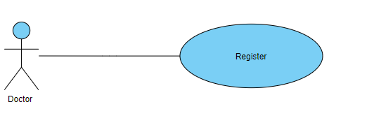

**Login**: To log in the app the user must enter username and password

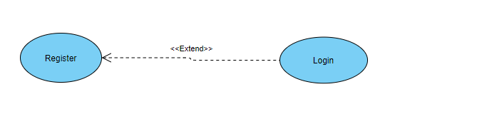

**Start Audio Recording:** Doctor start audio record to voice recording A patient's complaint

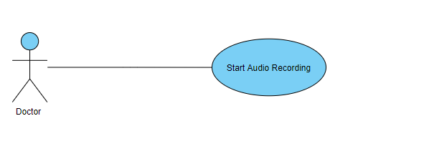

**send symptoms as text:** Doctor start write A patient's complaint

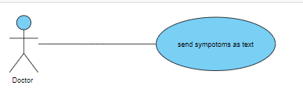

**Send audio or text to API:** API take audio to server to classification

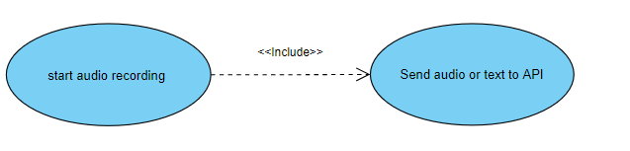

**Send audio or text to API:** API take text to server to classification

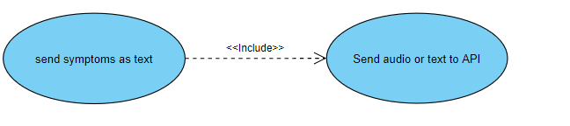

**Generate Symptoms, Disease, Treatments:** doctor Receive Symptoms and Diseases and Treatments that can use to make decision for patient Illness

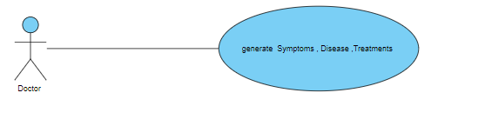

**Scan Patient QR Code:** Doctor Scan Patient QR Code To be able view patient medical history

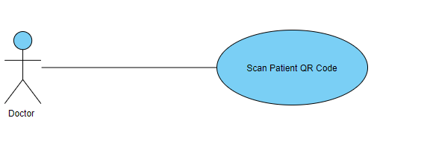

**Confirm result:** Doctor add record to patient medical history

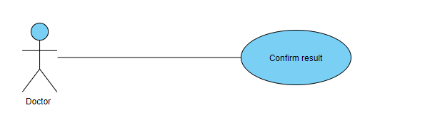

**Save Record:** send Record to server

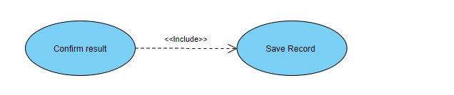

**View Patient Medical history**: Doctor after scan QR code of patient now he can view patient medical record

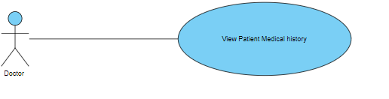

**Start Audio Recording:** patient start audio record to voice recording his complaint

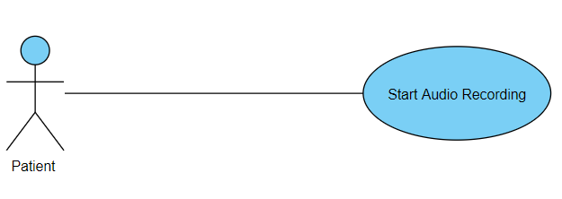

**send symptoms as text:** patient start writes his complaint

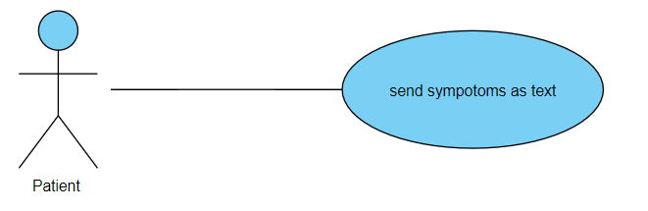

**Generate Symptoms, Disease, Treatments:** patient Receive Symptoms and Diseases and Treatments that can use to make decision for patient Illness

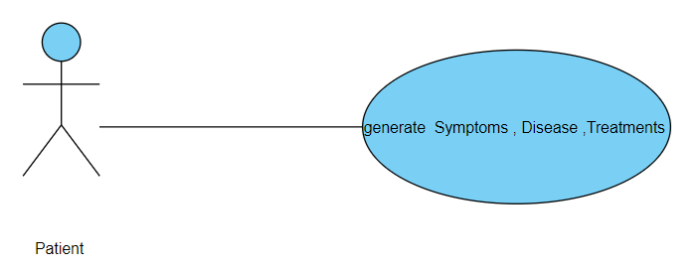

**send medical report to doctor: Patient** after receive his Medical Care report he can send to his doctor

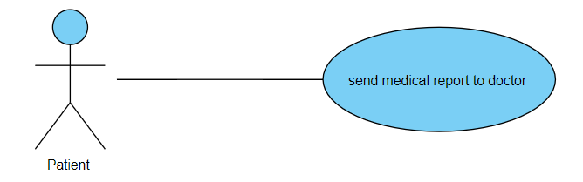

Add Old Medical History: patient add his old medical records

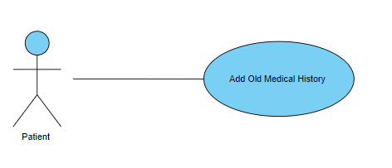

View Medical History: patient can view his medical records

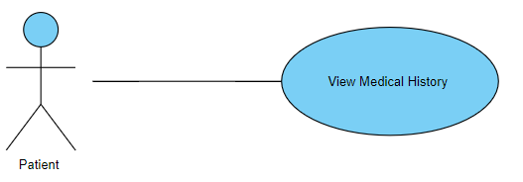

**Receive Audio:** server received the A patient's complaint

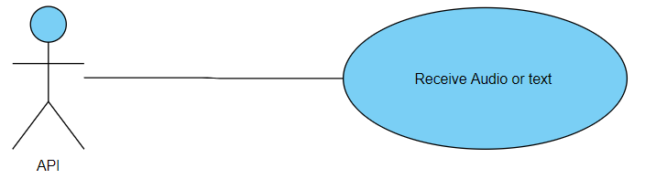

**Convert Audio TO Text:** NLP start preprocessing text by convert Audio TO Text

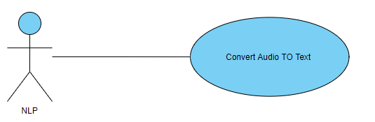

**Analysis Text:** NLP receive text after converting and start analysis text

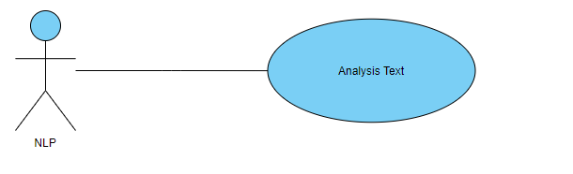

**Extract Symptoms**: NLP will Determines Symptoms after make Analysis to Text

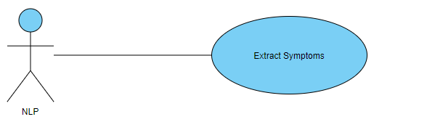

**classification Disease:** after Extract Symptoms Disease Classifier will receive Symptoms and predict Diseases

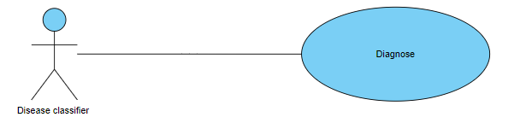

**Suggest Medicine**: after predict Diseases Treatments predictor will receive Diseases and Suggest Medicine

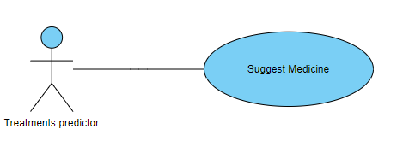

**Return Symptoms, Disease, Treatments:** after make classification Symptoms and Disease and predict with Treatments API will return what are Symptoms and Diseases and Treatments

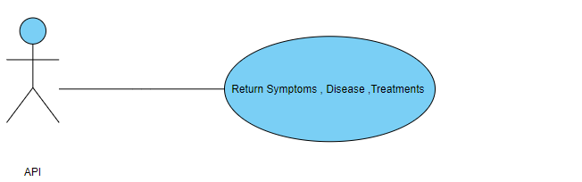

**save patient record** :APi saved record to add to patient medical record

